**Assignment**

1. Select a simple task: *"Write a Python function to check if a number is prime."*
2. Use different prompting strategies to generate the solution:
3. Zero-Shot – no examples.
4. One-Shot – one example provided.
5. Few-Shot – multiple examples provided.
6. Context-Managed – detailed prompt with constraints and instructions.
7. Record AI responses and refine prompts to improve code quality.
8. Request AI to optimize the logic for efficiency.
9. Compare results and document improvements.
10. **Sample Prompts**

* Zero-Shot:  
  Write a Python function to check if a number is prime.
* One-Shot:  
  Example: Input: 5 → Output: Prime. Now, write a function to check if a number is prime.

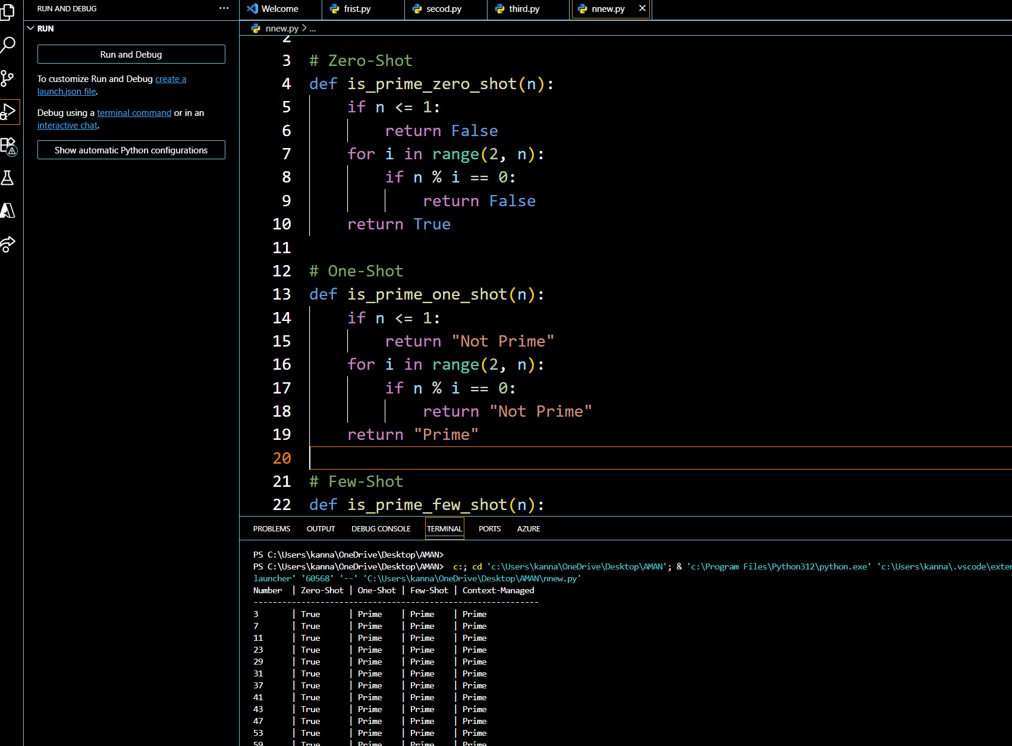

**Task: Mobile Data Usage Billing Application (1.0 Marks)**

**Objective:**

Use Python programming and AI-assisted coding tools to create an application that simulates mobile data billing for a telecom service provider.

Instructions

1. Use GitHub Copilot or Google Gemini to assist in writing the program.
2. Read the following inputs from the user:
   * Data Consumed (in GB)
   * Plan Type (Prepaid / Postpaid)
   * Additional Services Used (e.g., caller tune, OTT subscription, etc.)
3. Implement billing logic to calculate:
   * DC (Data Charges) – charges based on data consumption
   * VC (Value-added Charges) – charges for additional services
   * Tax – applicable tax on the total bill
4. Display an itemized bill showing:
   * Plan Type
   * Data Usage and Charges
   * Value-added Services and Charges
   * Tax
   * Total Bill Amount

Requirements

* Students must refer to their actual mobile bill for charge structure (data cost, service fees, taxes) to make the program realistic.
* AI assistance (Copilot/Gemini) must be used to generate and refine the initial code.

Deliverables

* AI prompts used for code generation.
* AI-generated Python code and any optimized version.

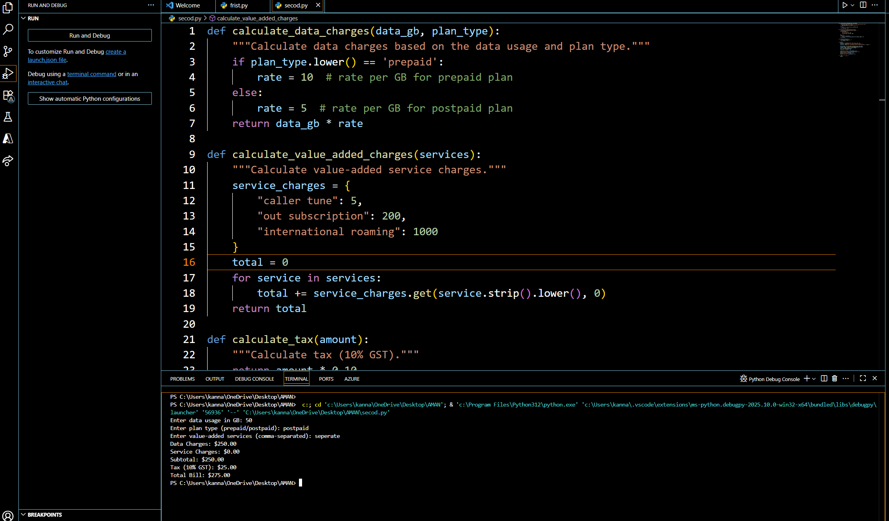

**Task: Develop an LPG Billing System (1.0 Marks)**

**Objective**

Apply your Python programming skills and utilize AI-assisted coding tools to build an application that calculates the LPG bill based on specified customer inputs and billing parameters.

Instructions

1. Use GitHub Copilot or Google Gemini to assist in writing and refining the program.
2. Read the following user inputs:
   * Cylinder Type (Domestic 14.2 kg / Domestic 5 kg / Commercial 19 kg / Commercial 47.5 kg)
   * Number of Cylinders Booked
   * Subsidy Amount (applicable only for domestic cylinders)
3. Refer to the given LPG Price List to determine the price per cylinder:
   * Domestic LPG (14.2 kg) → ₹905.00
   * Domestic LPG (5 kg) → ₹335.50
   * Commercial LPG (19 kg) → ₹1,886.50
   * Commercial LPG (47.5 kg) → ₹4,712.00
   * Delivery Charges (₹10 to ₹50)
4. Implement the billing formula:

Bill Amount = (Price per Cylinder × Quantity) - Subsidy (if applicable) + Delivery Charges

1. Calculate and display an itemized bill including:

* Cylinder Type
* Number of Cylinders
* Base Amount
* Subsidy
* Delivery Charges
* Total Bill Amount

